**Settings for Visual Studio Performance issues**

# TSv2 UI Build Page

TSv2 UI Website builds each and every folder.

To speed up the debug, set the build to “Build Page” in Website project properties as seen in the below screenshot.

This will only build the page at run-time which you are accessing the page.

**Note:** When-ever you get full latest code for website or checkout for first time; build the full website once manually

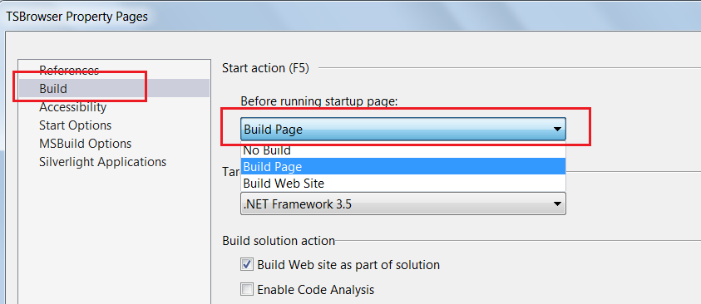

# Source Control

If source control is set as “Visual Studio Team Foundation” it may slow down the system.

Set it to “**None**” or “**AnkhSVN**” and check.

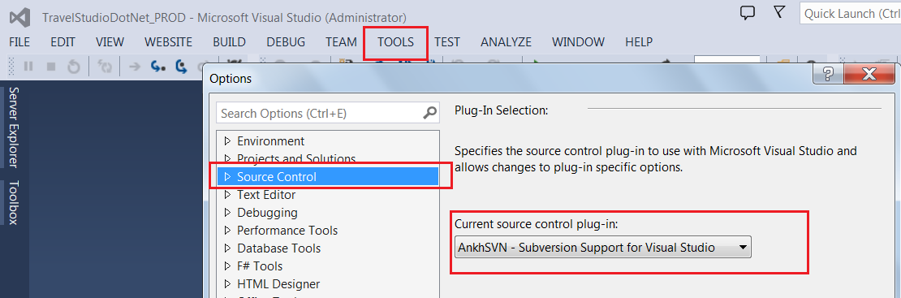

# Use IIS instead of IIS Express for debugging

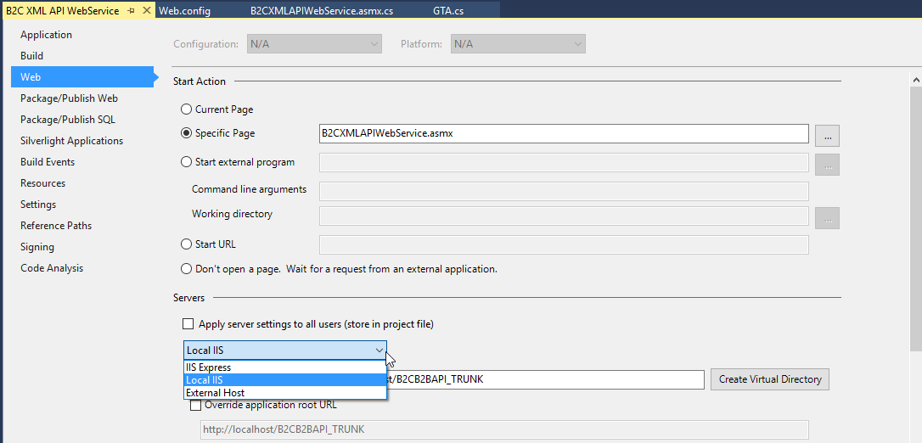

# Power options

Try setting power to high performance when directly connected to charger as seen below.

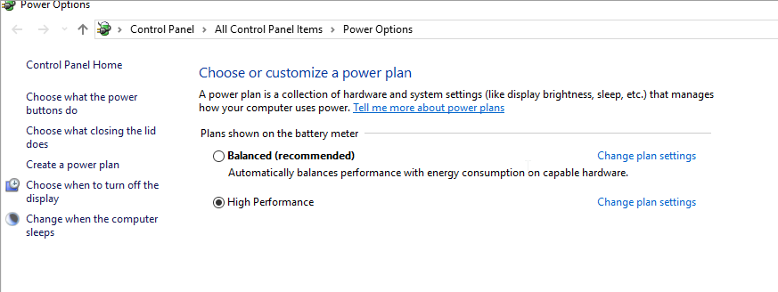

# Clean files

Clear temporary files once a month

1. Use disc cleanup
2. Clear C:\Windows\Temp
3. Clear C:\Users\[User Name]\AppData\Local\Temp
4. Clear Temp Asp.net files - After delete first build will be slow.

C:\Windows\Microsoft.NET\Framework64\v2.0.50727\Temporary ASP.NET Files

C:\Windows\Microsoft.NET\Framework64\v4.0.30319\Temporary ASP.NET Files

C:\Windows\Microsoft.NET\Framework\v4.0.30319\Temporary ASP.NET Files

C:\Windows\Microsoft.NET\Framework\v2.0.50727\Temporary ASP.NET Files

# Set Batch as false

Sometimes you make get error for duplicate usercontrols in aspnet temp files.

Add  batch=”false” in the compilation line in tsv2 web.config file to resolve the temporary files error.

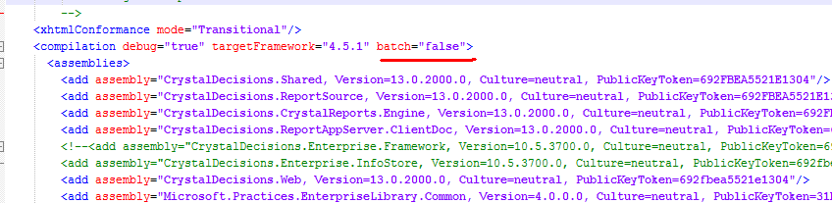

Please check if compilation slows down after this is set. If yes please get in touch with Development management team.

# Debugging Issues (Out of memory)

You may also get out of memory in some cases like one shown below in TSV2: Booking->Service Search.



* VS2013 uses IIS express by default, change to IIS as mentioned in above point.
* Close IIS express, delete all breakpoints. Run and see if it works.
* If it does not work then right click login page and run it in browser. Log-in and check if it works. If it works then try running the solution in debug mode
* For debugging API attach the devenv.exe of TSDOTNETAPI project from TSV2 as show in the screenshot below :

Incase you are not able to debug code try the following setting

<http://weblog.west-wind.com/posts/2013/Nov/21/Visual-Studio-2013-Could-not-evaluate-Expression-Debugger-Abnormality>

# Runtime Errors .NET 4.5

1. TSDOTNETAPI : On invoking a web method,get this following error:

Soln: <add key="vs:EnableBrowserLink" value="false"/> in the web.config file.



# Disable request/response logging

Keep request/response logging disabled and enable only when required.

# Debug off

When you want to test without debugging you can set debug Off in web.config. it will avoid generation of additional files like pdb and speed up process.

# Avoid rebuilding TSv2 UI solution frequently

Avoid rebuilding entire TSv2 UI solution frequently. The compilation of Multilingual projects and ServiceProxy projects are slow.

# Other settings

Go to Build -> Configuration Manager -> Uncheck the build for Agent GUI in case you are not working on the agent portal. This will reduce the website build time.

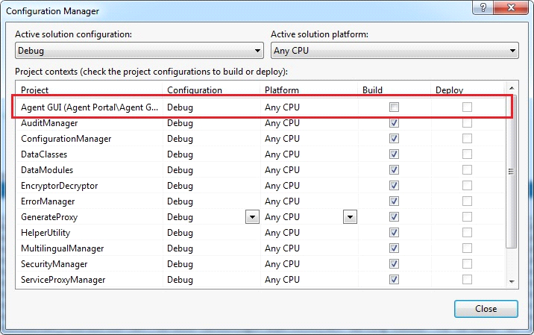

* For stack overflow sometimes clearing the temp files was helping

C:\Windows\Microsoft.NET\Framework64\v4.0.30319\Temporary ASP.NET Files

* Also need to clear the WebsiteCache

C:\Users\savira\AppData\Local\Microsoft\WebsiteCache

To make VS2013 faster the below settings are advised

* Keep the Color Theme as “Light”
* Uncheck the “Automatically adjust visual experience on client performance”, “Enable rich client experience” and “Use hardware graphics acceleration if available”.

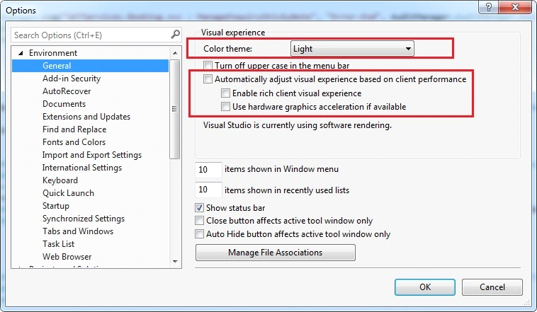

* Also uncheck these settings in the Synchronized settings.

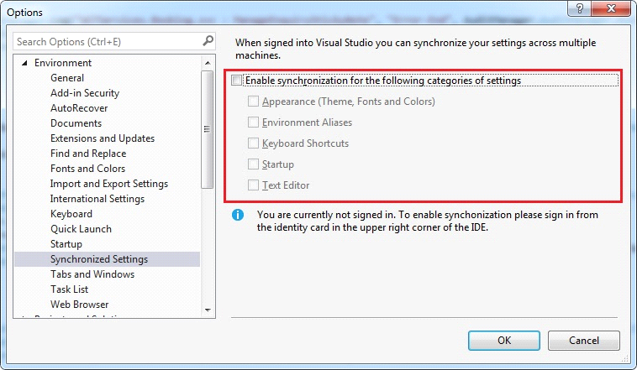

* Tools -> Options -> Debugging -> Edit & Continue (uncheck the option)

**Note:** Try after unchecking, if there is no difference Check it again and keep the setting as checked

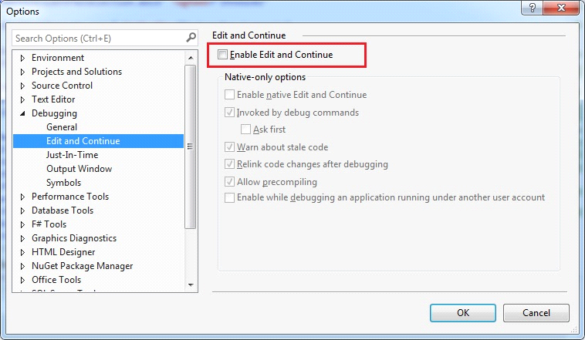

* Go to Tools>Options>Environment>Add In Security.  
  You will see a checkbox with “allow add in components to load” .Just uncheck it. Restart the IDE.

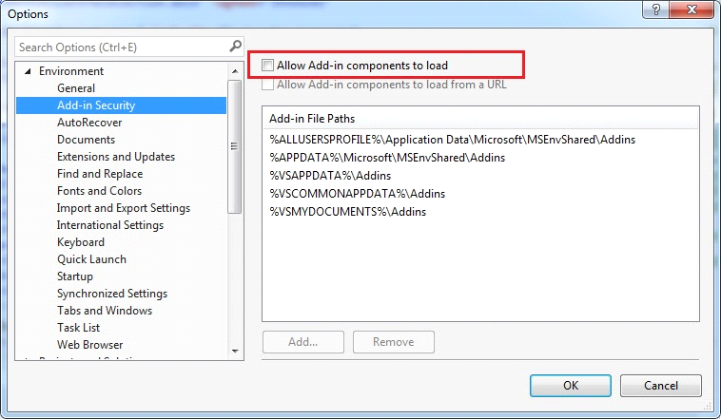

* Tools > Options > Environments>”Extensions and Updates” and disable “Automatically Check for Updates

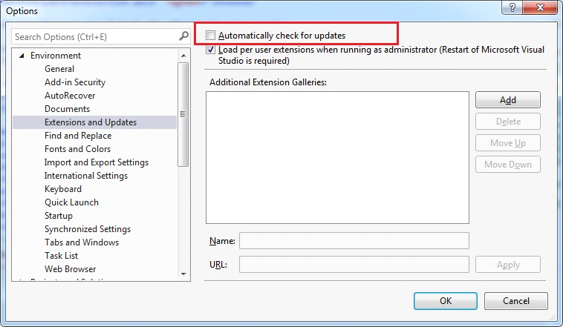

For smoother navigation between pages keep the Preview selected items as OFF.

